가성비 앱 2차 코드리뷰

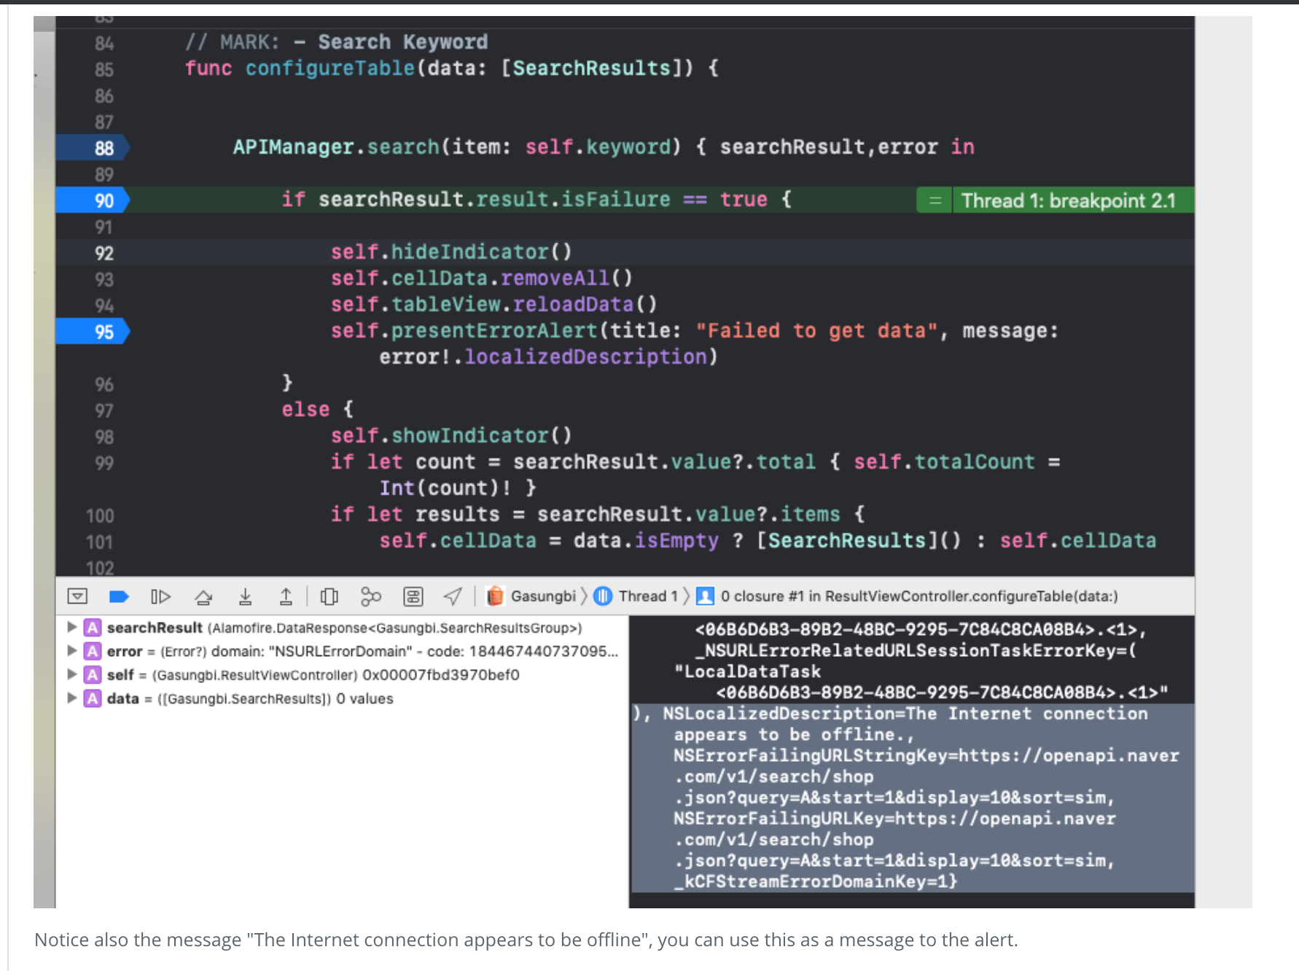 **Gasungbi/Controller/Result Table View Controller/ResultViewController.swift** **2**

Notice also the message "The Internet connection appears to be offline", you can use this as a message to the alert.

REQUIRED

As you can see below, the Price View is still not functional. An empty view shows in all cases we select a row in the table view:

[](https://udacity-reviews-uploads.s3.us-west-2.amazonaws.com/_attachments/1392/1576147348/Untitled.gif)

 **Gasungbi/Controller/Favorite Table View Controller/FavoriteViewController.swift** **1**

Consider using debugPrint() for printing messages to the console.

Check out the documentation: <https://developer.apple.com/documentation/swift/1539920-debugprint>.

There are some extra benefits from the plain print() statement when debugging as the name suggest. <https://stackoverflow.com/a/43297840>

SUGGESTION

We can remove this empty app delegate method because , other than being empty, it is optional.

